**IMPORTANCE OF ENGLISH FLUENCY IN I.T SECTOR WITH REFERENCE TO SELECT ASPIRANTS**

1. S. Janani, M.A II year, Govt. Arts and Science College, Arakkonam
2. Dr.P.Samuel, Assistant Professor of English, Govt. Arts and Science College, Arakkonam

**INTRODUCTION**

Like any other language used for day-to-day communication, “English” may seem to be just an aid for communication. But it stands predominant among the world languages due to its varied prevalence and usage in almost every sector in the industrial world. Usage of English in every sector lead to a easy and efficient way of communication, enabling a mass broadcast of knowledge sharing among the people. It stands as an irreplaceable language for mass communication.

Information Technology is one such field in the industry which has the wide spread of English language among the world. It influences Employees to develop themselves with updated technologies to stay sustained in the leading IT sector. IT sector is a world-wide connected industry in which people around the world work for various clients around the world. International client management is made easy and efficient through English since English is the most preferable communicative language in the world. Programming languages and software development tools are mostly available in English enabling world wide spread of knowledge and information sharing, besides technical part. English is mainly focused in IT sector to maintain good interpersonal relationships among the employees of the firm. Soft skill communication is much mandatory for aspirants who seek job in IT sector. A good knowledge in communicative English helps an individual to maintain better interpersonal relationship, client management, updating himself in technology, to be better presenter of various issues in group discussions and communication which is both verbal and electronically which is utmost essential in day-to-day official life.

In India, many IT firms are international, who develop and maintain software’s for clients around the world. These companies prioritize English communication to be one of the major qualifications from the aspirants because they must be efficient to express their opinions clearly to the client as well as the management. Efficient communication is most needed to solve the problems rising through long distance conversations, indirect communication and mass communication like electronic mails, letters and meetings etc which doesn’t involve in-person meetings. Employees may be called upon to explain how a particular system works or to present a proposal for a new project. Confidence, engaging and clear oral presentation skills will help them to succeed in many promotions. A good IT professional not only listens carefully to project requirements, but them also listens for subtexts and unsolved problems. Already, new and greater demands are being made as to the core qualifications of individuals, as well as to their understanding and knowledge of the consequences of Information Technology for the work. In a society which is becoming increasingly dependent on information and data processing of knowledge, great demands are therefore made, that the individual should have a solid and broad education foundation on which to build their wisdom. The world is brought closer, and the world’s economy will be quickly and easily formed all over the globe, amidst of linguistic barriers and geographic boundaries can be torn down as people share ideas and information with each other.

Through English language proficiency is not only for career development, its important in the corporate world is widely recognized. This paper aims to find out the importance of English in IT field by conducting a survey among employee. Due the global market, the requirements of English language are likely to increase every year and employees without adequate English language skills may find it very challenging to grow professionally. Considering all the above factors of increasing expectation of the firm from the individuals, English is considered to be most essential tool to get placed in IT sector.

**PERFACE TO THE STUDY**

Development of English knowledge among the IT workers and then, the difficulties of IT Employees from Tamil Nadu.

**PLACE OF STUDY**

Cognizant Technology Solution

It is nearby Old Mahabalipuram Road, Chennai.

IT industry staff

They studied both English and Tamil Medium

**FIELD STUDY TOOLS**

Questionnaire of statistical data for study

**STATISTICAL COLLECTION**

For this project, 20 IT employees have been selected for her study. The investigator took and obtained responses through Google form.

**NEED AND PURPOSE OF STUDY**

1) The main purpose of study is importance of communication in IT sector.

2) The first and the foremost purpose are to develop communication.

3) Assuring that maximum in the environment to speak in English

4) Guidance given through the non-native speakers to develop their

communication.

5) To give proper counseling to needy employees to learn English.

6) Encouraging that communication will edify them in their carrier development.

**FIELD STUDY WORK PLAN**

Selection of site for study

Selecting the tool for study

Preparation of Quiz list for statistics collection

Statistical Collection

Statistical Analysis

Knowing the Details of the problem from the Result

Consulting and deciding on a solution

Implementation The-solution

**IMPORTANCE OF ENGLISH FLUENCY IN IT SECTOR WITH REFERENCE TO SELECT ASPIRANTS**

**QUESTIONAIRE FOR IT ASPIRANTS**

1. Name :
2. Date of birth :
3. Age :
4. Gender :
5. Male
6. Female
7. Trans Gender
8. Mobile number and Email Id:
9. School studied:
   1. Government
   2. Private
   3. CBSE
   4. ICSE
10. Medium of education:
    1. English
    2. Tamil
    3. Hindi
    4. Others
11. Course studied:
    1. Arts
    2. Engineering
    3. Diploma
    4. Medical
12. Educational Qualification:
    1. Under Graduate
    2. Engineering
    3. Post Graduate
    4. Diploma
13. Communication skill improved through:
    1. English newspaper
    2. English movie
    3. Coaching Centre
    4. Mobile phone
14. Reason to join IT sector:
    1. High salary
    2. Multiple career paths
    3. Self interest
    4. To work in city environment
15. Whether English Fluency essential in this field:
    1. Agree
    2. Strong Agree
    3. Not agree
    4. Strongly disagree
16. Whether English Fluency helpful for next level promotion:
    1. Agree
    2. Strong Agree
    3. Not agree
    4. Strongly disagree
17. Promotion scope in this field:
    1. Developer
    2. Tester
    3. BPO (Voice and non-voice)
    4. Others
18. Years of Experience in this field:
    1. 1-3 Years
    2. 3-5 Years
    3. 5-7 Years
    4. 7+ Years
19. Gross Annual income:
    1. 1-3Lakhs per Annum
    2. 3-5Lakhs per Annum
    3. 6-8Lakhs per Annum
    4. 9-12Lakhs per Annum
20. English fluency test certificates:
    1. BEC
    2. IELTS
    3. TOEFL/BULAT
    4. No certificate

**STATISTICAL ANALYSIS**

The study was conducted through questionnaires and interview with IT employees. Through this study, we learned about the difficulties faced by IT employees from Tamil Nadu. There are some kinds of problems to communicate in English such as

1. Lack of confidence
2. Unwanted Gossips
3. Low motivation
4. Discrimination
5. Fear

**STUDY RESULT**

For this project, 20 Employees have been selected. Totally, 17 questions have been asked in which 9 of them were basic question like name, date of birth, age, gender etc. and others were survey questions.

Questions and Responses have been listed below with percentage basis.

**BASIC INFORMATION**

1. Name of the employee

2. Among 20 employees, 17 employees are (22-30) years old and 3 employees are (31-38) years old.

3. Among 20 employees 65% employees are male and 35% employees are female.

4. Among 20 employees, 25%employees were studied in Tamil Medium and 75% employees were studied in English Medium.

5. Among 20 employees, 25% employees werestudied in government school, 65% employees were studied in private school, and 10% employees were studied in CBSE School.

6.Among 20 employees, 40% employees were studied Engineering and 60% employees were studied Arts.

7. Among 20 employees, 45% employees were under graduates and 55% employees were post graduates.

**RESPONSES RECEIVED FROM FOR IT ASPIRANTS**

1. “Communications skills improve through” among 20 employees, 30% employees have chose option A (English Newspaper), 40% employees have chose option B (English Movie), 30% employees have chose option D (Mobile phone).

2. “Reason to join IT sector” among 20 employees,among 20 employees, 25% employees have chose option A (High Salary), 30% employees have chose option B (Multiple Career Paths), 40% employees have chose option C (Self Intrest),5% employees were choose option D (To Work In City Environment).

3. “Whether English fluency essential in this field” among 20 employees, 65% employees have chose option A (agree), 35% employees have chose option B (strong agree).

4. “Whether English fluency helpful for next level promotion” among 20 employees, 75% employees have chose option A (agree), 25% employees have chose option B (strong agree).

5. “Promotion scope in this field” among 20 employees, 60% employees havechose option A (Developer), 15% employees have chose option B (Tester), 20% employees have chose option C (voice and non-voice),5% employee have chose option D (others).

6. “Years of experience in this field” among 20 employees, 60% employees have chose option A (1-3 years),25% employees have chose option B (3-5 years), 5% employee have chose option C(5-7 years), 10% employees have chose option D (7+ years).

7. “Gross annual income” among 20 employees, 35% employees have chose option A (1-3 Lakhs per annum), 55% employees have chose option B (3-5 Lakhs per annum),5% employee have chose option C (6-8 Lakhs per annum), 5% employee have chose option D (9-12 Lakhs per annum).

8. “English fluency test certificates “among 20 employees, 10% employees have chose option A (BEC), 10% employees have chose option B (IELTS), 80% employees have chose option D (No Certificates).

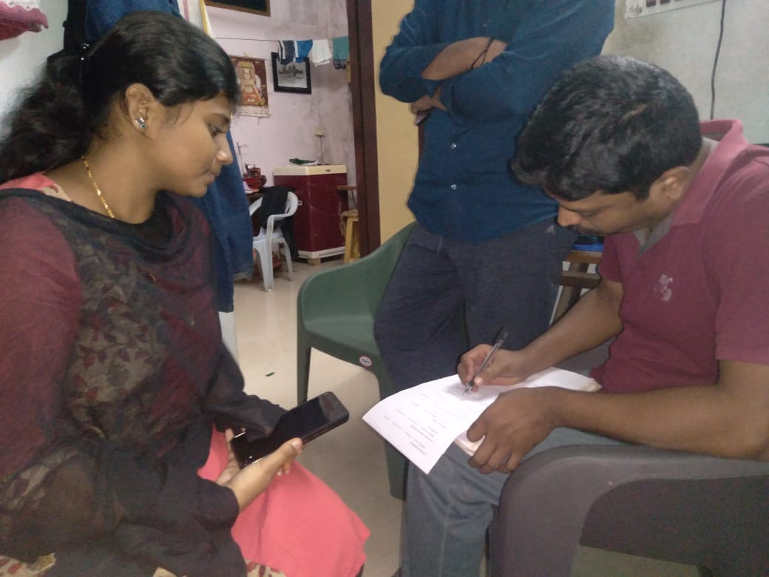**PHOTOGRAPHS**













**IMPLEMENTING THE SOLUTION**

They should develop the reading habit and, they should write of can their own and make conversation by practicing dialogues and able to deliver high quality presentations. The three major keys to develop communication skills are

1. Listening
2. Speaking
3. Reading/Learning
4. Writing

**FIELDS OF INTEREST**

1. Developing Successful career

For leading a successful and sustainable career in IT field, English is essential. Since communication plays a major role in the field of IT, IT firms choose to work with persons who are well efficient in English rather than native speakers even though their technical aspects sound good. Better communicative ability may resolve unwanted queries and confusion.

1. Official Business language

Not legally, English serves as the most used official Business language in every part of the world. This may be due to its wide spread of people who speaks them are living all over the world in various firms providing flexibility to access and maintain relationships and business in the global market.

1. Internet Accessibility

Internet is now-a-days presented as ultimate source of knowledge which provides information about almost everything that exists in universe. Most of the internet contents are majorly available in English like major websites, search engines, social platforms, blogs etc. which may be accessed only through knowing English. Even English can be learnt simply using Internet through YouTube, E-dictionary apps and other educational platforms available in internet.

1. Programming Languages

Most of the programming languages available and those yet to be developed in the upcoming years are mainly using English since the development must reach worldwide market for usage and to acquire clients and employees to work in these developments.

1. Soft skill communication

Apart from developing the technical aspect in one’s career, English also plays an inconvincible role in developing one’s confidence and mannerism. Now a day’s soft skill training is taken for fresh recruits in IT enabling them to learn interpersonal skills and communication of behaving with others, presenting before a group of people and communicating in electronic modes in order to make them sustainable and efficient in the IT sector.

**CONCLUSION**

In conclusion, language barriers are major problem currently faced by employees in today’s economic workforce. To solve problems arising out of this, internet and websites are now familiar to improve English knowledge.As our survey concerned,the investigatorhas collected the basic information of the employees then followed by the questionnaires. In that 25% employees were from Tamil medium while 75% are English medium, but as the survey done both Tamil and English medium employees says that English communication is very much important in IT environment. The same has been reflected in the next level promotion question most of them have given English as most important tool.As the communication improved through 40% of employees suggest that they have learned communication through watching English movies, while 30% improved through mobile phone and remaining through newspaperit reflects that most of them watching English movie with subtitles which helps their English communication. Both the highly experienced employees and low experienced employees both suggest English is more vital when comes to our IT field. So finally, the investigatorconclude that English is most important factor while comparing all the parameters in the survey like experience, salary, medium of instruction.

**APPENDIX**